Report: Laboratory work 4

**Determining and removing drawbacks of exponential and running mean. Task 2**

Team #1: Viktor Liviniuk, Alina Liviniuk

In this work we determine conditions for which broadly used methods of running and exponential mean provide effective solution and conditions under which they break down.

**Part 1. Comparison of the traditional 13-month running mean with the forward-backward exponential smoothing for approximation of 11-year sunspot cycle**

In this work we use given data (year, month, monthly mean sunspot number).

First, we run 13-month running mean:

𝑅̅=(1/24)𝑅𝑖−6+(1/12) (𝑅𝑖−5+𝑅𝑖−4+⋯+𝑅𝑖−1+𝑅𝑖+𝑅𝑖+1+⋯+𝑅𝑖+5)+ (1/24)𝑅𝑖+6

Second, we run forward-backward exponential smoothing of monthly mean sunspot number with different smoothing constant 𝛼.

Third, we tried to find a smoothing constant 𝛼, that would work better, than running mean. Following plots show dependencies of indicators from alpha.

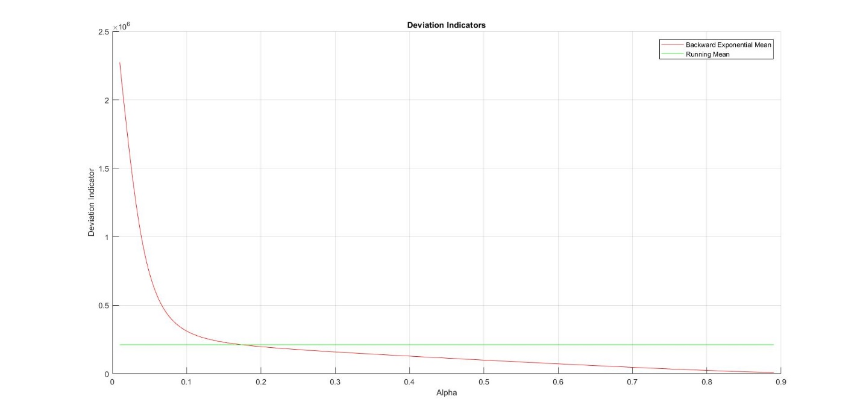

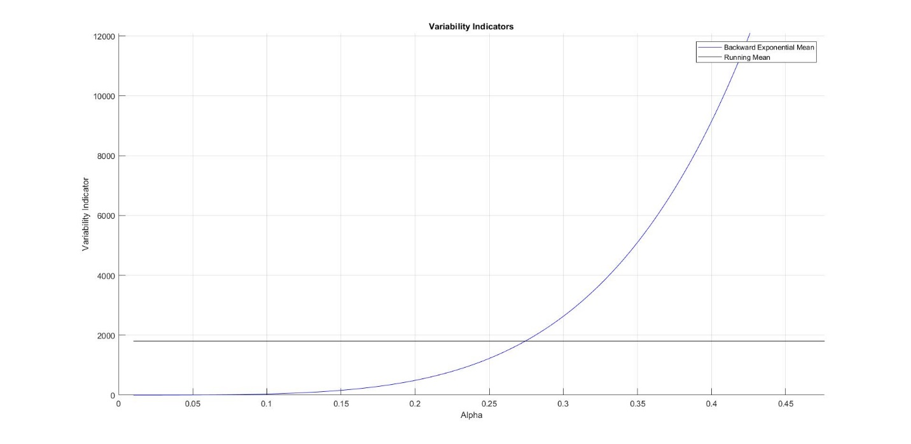

Deviation indicator in forward exponential is lower (better), than in running mean, when 𝛼 is greater than 𝛼 = 0.174.

Variability indicator in forward exponential is lower (better), than in running mean, when 𝛼 is less than 𝛼 = 0.274.

So, forward exponential works better than running mean when 𝛼 = [0.174; 0.274].

The following plot shows the result with 𝛼 = 0.22. 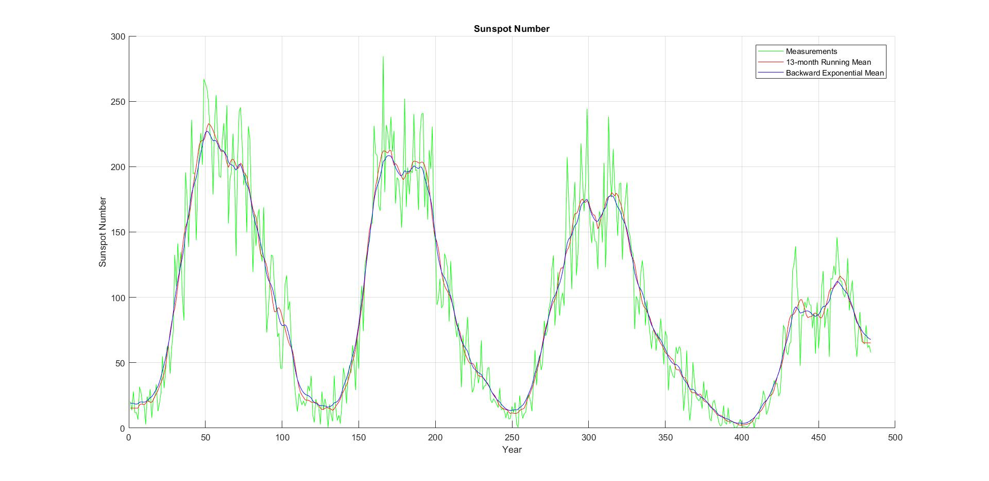

**Part 2. 3d surface filtration using forward-backward smoothing.**

We reconstructed the 3D surface on the basis noisy measurements of the surface in conditions of uncertainty.

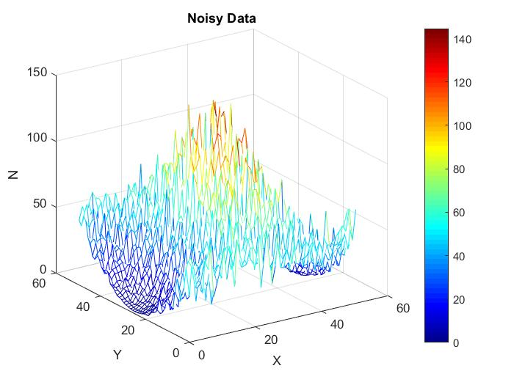

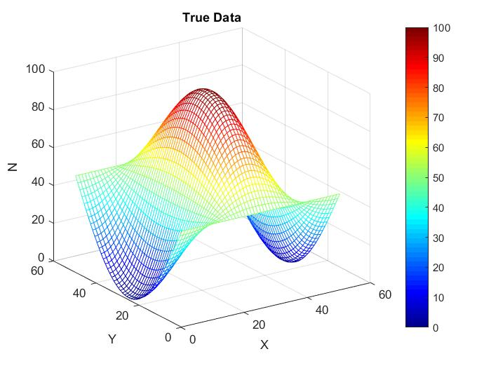

The variance of deviation of noisy surface from the true one is 120.6

The following visualization is forward-backward exponential smoothing of noisy data with smoothing constant 𝛼=0.335

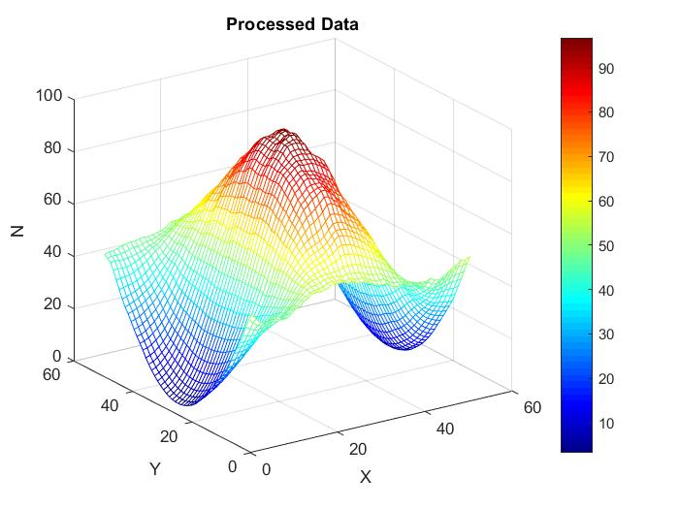

The variance of deviation of this surface from the true one is 7.1 – much lower, than with noisy data. This mean, that our approximation of surface better represent the real surface and the method works great.

Conclusion.

Main drawback of forward exponential mean method, the shift, was eliminated in backward exponential mean method. The backward method worked better for processing sunspot number data, but not with all smoothing constants. Optimal smoothing constant 𝛼 should be determined for the method to perform better.

Deviation and variability indicators can be used as criteria for a good evaluation method. Also, for finding optimal smoothing constant.

Backward exponential mean method can be applied to smooth surface measurements.

Files with matlab code are attached.